***Worksheet 1***

***Grade 3***

***Q1: Add the following.***

1. ***4532 + 5225***
2. ***7859 + 6984***
3. ***7834 + 4035***
4. ***6783 + 4003 + 6932***

***Worksheet 2***

***Grade 3***

***Q2: Subtract the following.***

1. ***9345 – 5876***
2. ***7629 – 4872***
3. ***6993 – 2987***
4. ***2589+5683-4983***
5. ***7432 - 5411***

***Worksheet 3***

***Grade 3***

***Q3: Write in words.***

1. ***6789***
2. ***7032***
3. ***9345***
4. ***6300***
5. ***8506***

***-------------------------------------------------------------------------------------------------------------***

1. ***4690***

***-------------------------------------------------------------------------------------------------------------***

1. ***3999***

***-------------------------------------------------------------------------------------------------------------***

***Worksheet 4***

***Grade 3***

***Q: Complete the following.***

1. ***4000 + 500 + 60 + 4 = -----------------***
2. ***8000 + 300 + 50 + 9 = -----------------***
3. ***2000 + 700 + 60 + 3 = ------------------***
4. ***3000 + ----------- + 70 + 2 = 3672***
5. ***----------- + 100 + 30 + 6 = 9136***
6. ***5000 + 600 + ----------- + 4= 5694***
7. ***6000 + 900 + 700 + ------------ = 6971***
8. ***5000 + 500 + --------- + 5 = 5555***
9. ***6000 + 100 + 80 + 6 = -------------***
10. ***7000 + 500 + 40 + 5 = --------------***
11. ***9000 + 500 + 40 + 1 = -------------***

***Worksheet 5***

***Grade 3***

***Q: Complete the following number jumps.***

1. ***3, 6, 9, 12, 15, --------, ---------, ---------, ---------***
2. ***5, 10, 15, 20, 25, ---------, -----------, -----------, ----------***
3. ***100,200,300,-------,---------,--------,--------,--------***
4. ***331,431,531,---------,-----------,-----------,----------***
5. ***2300,2500,2700,----------,-----------,-----------,------------***
6. ***400,600,800,1000,-------,--------,---------,----------***



***Worksheet 6***

***Grade 3***

***Q: Solve the following.***

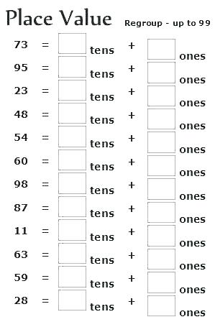

***Worksheet 7***

***Grade 3***

***Q: Solve it.***

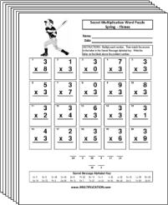

***Worksheet 8***

***Grade 3***

***Q: Solve the following.***

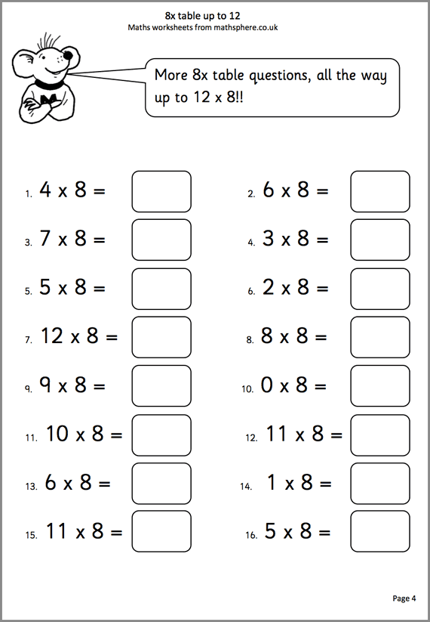

***Worksheet 9***

***Grade 3***

***Q1: Ali has 5489 rupees. Asim has 6872 rupees. How many total rupees they both have altogether?***

***Q2: Mr.Lim bought a sofa set Rs 6784 and a set of dining table Rs 7458. Mr Lim has given Rs 18000. How much change did he has receive?***

***Q3: In a fruit basket there is a 456 apples. 389 less bananas then apples. How many apples and bananas are there altogether in a fruit basket?***

***Worksheet 10***

***Grade 3***

***Q: Complete the following.***

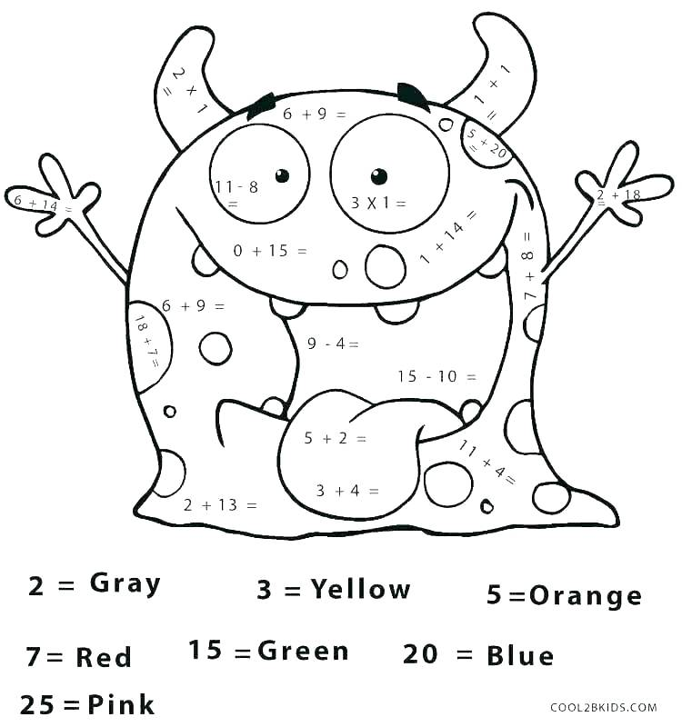

***Grade 2***

***Worksheet 1***

***Q: Write the numbers in words.***

1. ***456***
2. ***748***

***-----------------------------------------------------------------------------------------------***

1. ***670***

***-------------------------------------------------------------------------------------------------------------***

1. ***900***

***-------------------------------------------------------------------------------------------------------------***

1. ***505***

***-------------------------------------------------------------------------------------------------------------***

1. ***899***

***-------------------------------------------------------------------------------------------------------------***

***Grade 2***

***Worksheet 2***

***Q: Where does each digit stands for?***

1. ***7 8 3***
2. ***4 0 9***
3. ***7 0 0***
4. ***6 7 3***

***Grade 2***

***Worksheet 3***

***Q: Add the following.***

1. ***523 + 442***
2. ***460 + 639***
3. ***756 + 479***
4. ***899 + 494***
5. ***878 + 447***

***Grade 2***

***Worksheet 4***

***Q: Subtract the following.***

1. ***584 - 234***
2. ***756 – 424***
3. ***693 – 479***
4. ***756 - 489***
5. ***821 – 467***

***Grade 2***

***Worksheet 5***

***Q: Complete the following.***

1. ***400 + 20 + 3 = ----------***
2. ***600 + 40 + 5 = ----------***
3. ***900 + 0 + 6 = ----------***
4. ***500 + 50 + 0 = -----------***
5. ***0 + 60 + 9 = ----------***
6. ***300 + ------- + 4 = 374***
7. ***800 + 60 + -------- = 869***
8. ***--------- + 20 + 1= 721***
9. ***--------- + -------- + --------- = 990***

***Grade 2***

***Worksheet 6***

***Q: Solve it.***

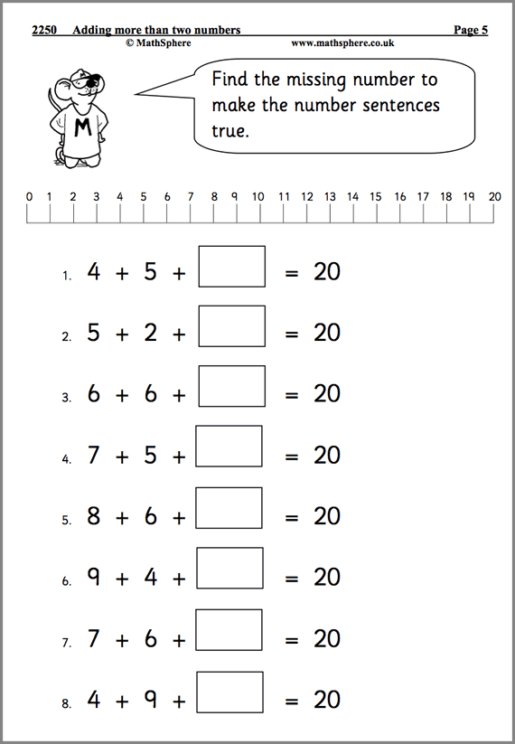

***Grade 2***

***Worksheet 7***

***Q: Solve it***

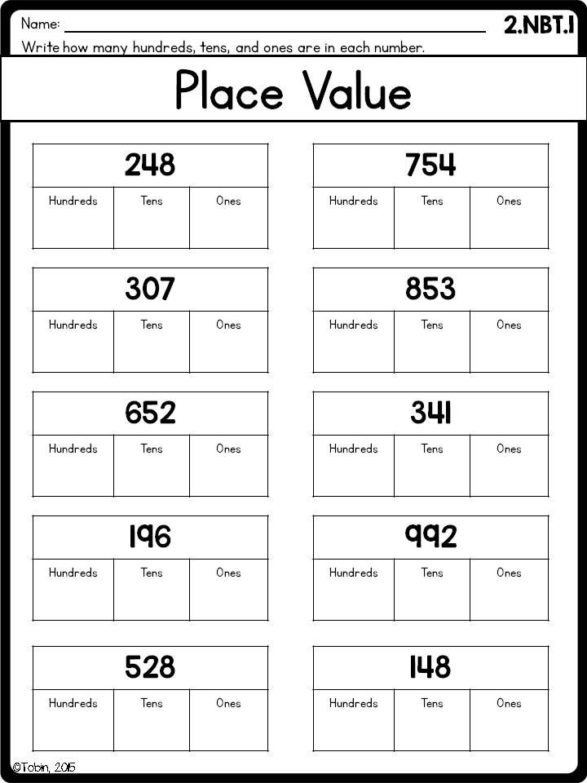

***Grade 2***

***Worksheet 8***

***Q: Complete it.***

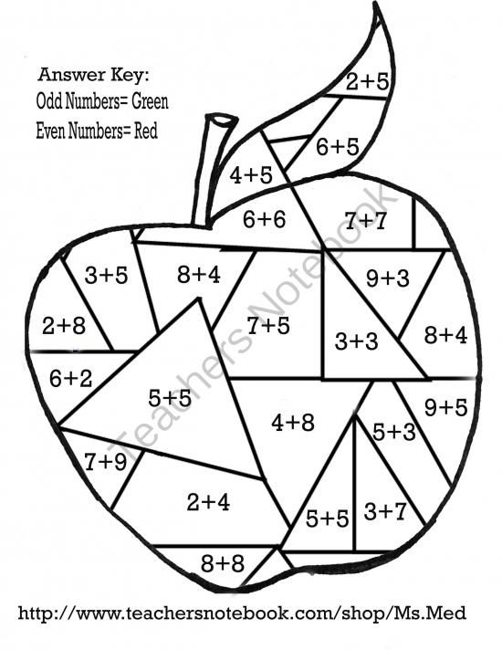

***Grade 2***

***Worksheet 9***

***Q: Solve it.***

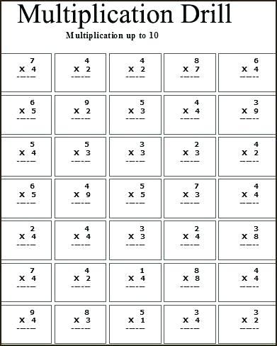

***Grade 2***

***Worksheet 10***

***Q1: Jenny is reading a book. She read 85 pages yesterday and 33 pages today. How many pages did she read in two days?***

***Q2: In a primary school there are 355 boys. There are 37 more girls than boys. How many pupils are there in the school altogether?***

***Q3: In the last month Jenny saved RS 125 Peter saved RS 87 and Jony saved RS 138. How muc did the three of them save altogether?ss***

***Grade 1***

***Worksheet 1***

***Q: Count and it.***

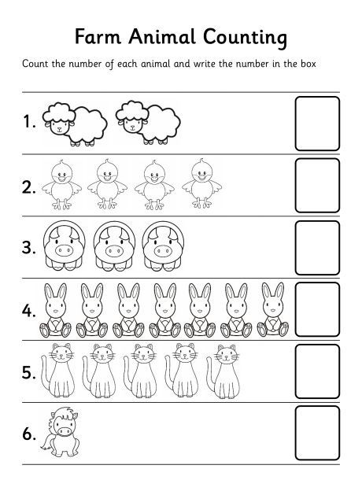

***Grade 1***

***Worksheet 2***

***Q: Circle the correct number.***

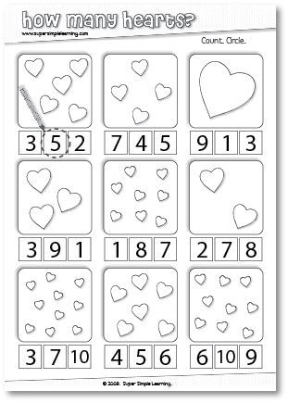

***Grade 1***

***Worksheet 3***

***Q: Match with the correct number.***

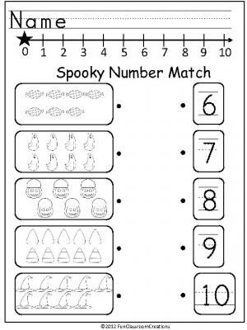

***Grade 1***

***Worksheet 4***

***Q: Complete the number bonds.***

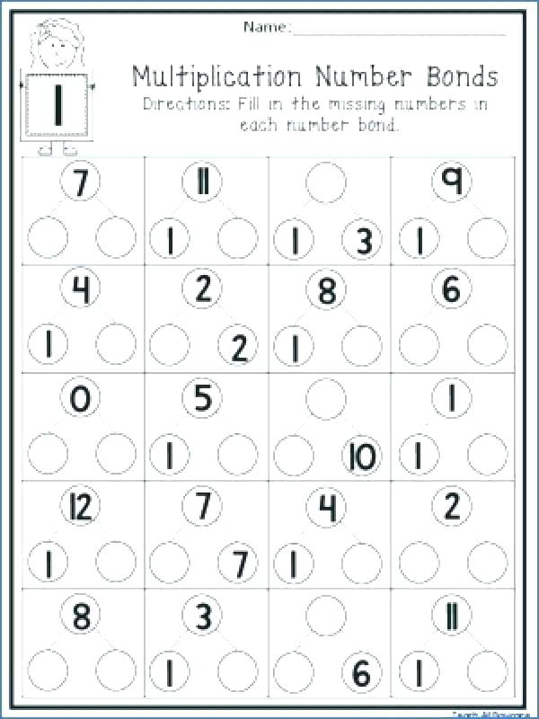

***Grade 1***

***Worksheet 5***

***Q: Add the following.***

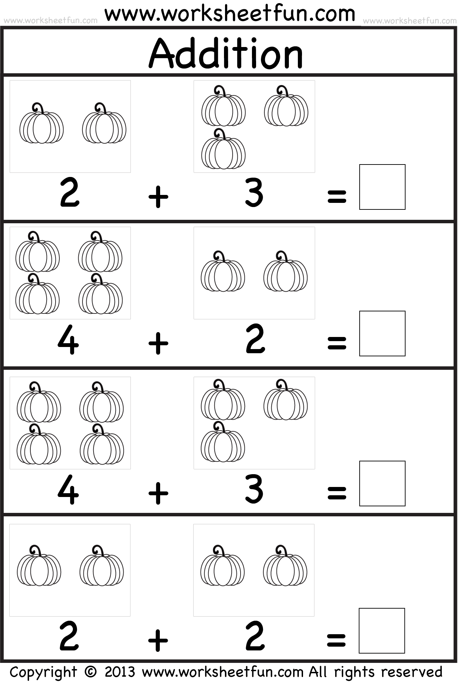

***Grade 1***

***Worksheet 6***

***Q: Addition.***

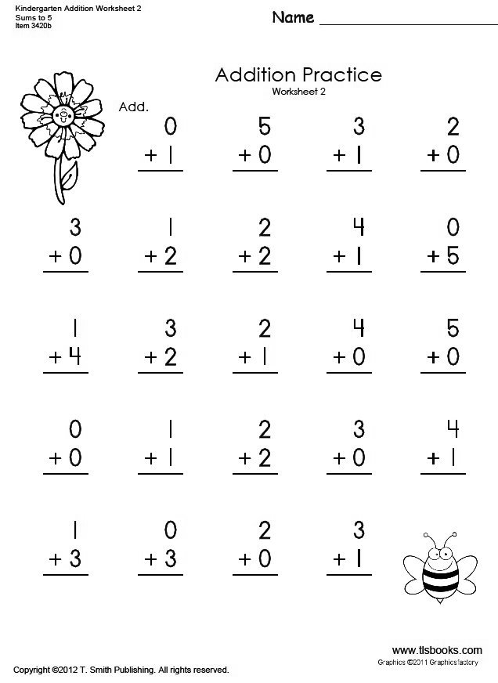

***Grade 1***

***Worksheet 7***

***Q: Complete the number bonds.***

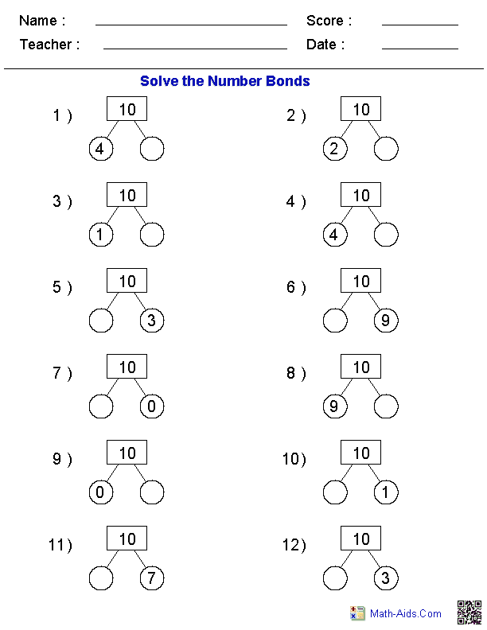

***Grade 1***

***Worksheet 8***

***Q: Circle the greater number.***

ork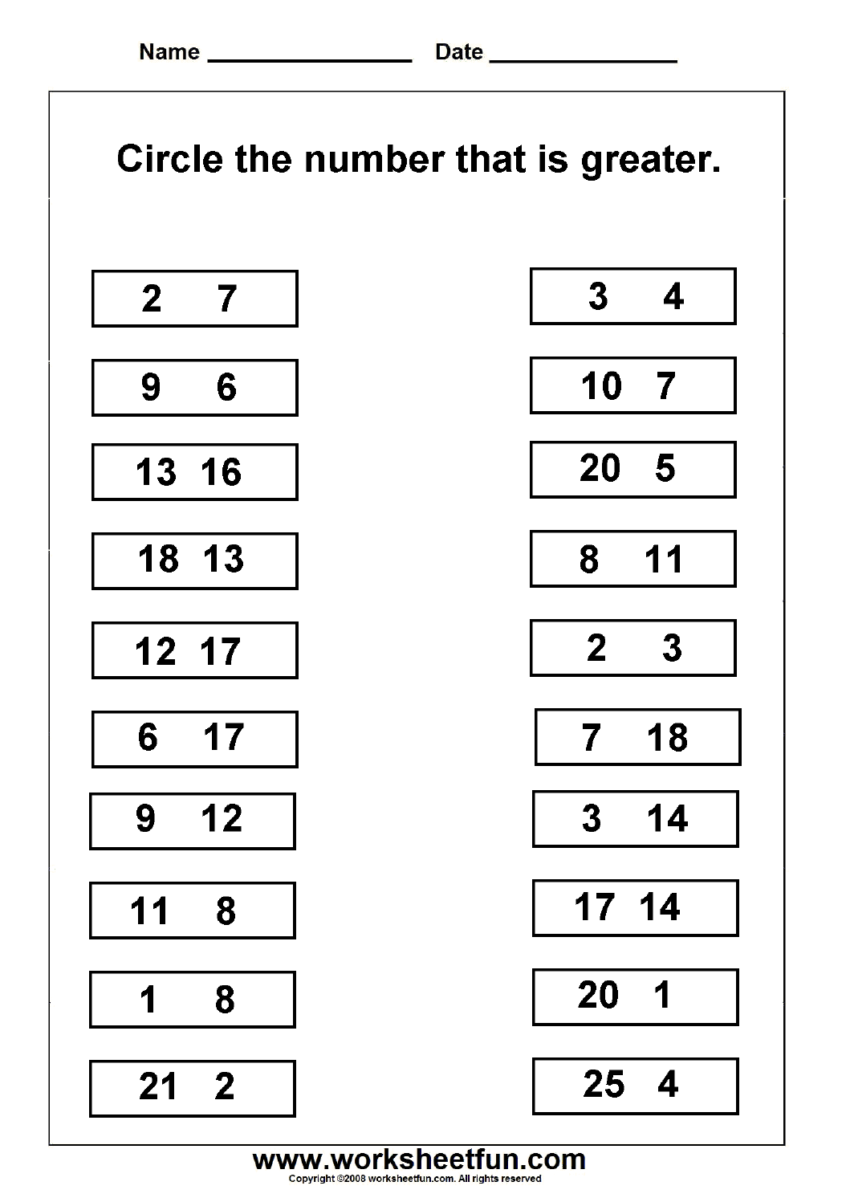

***Grade 1***

***Worksheet 9***

***Q: Write in words.***

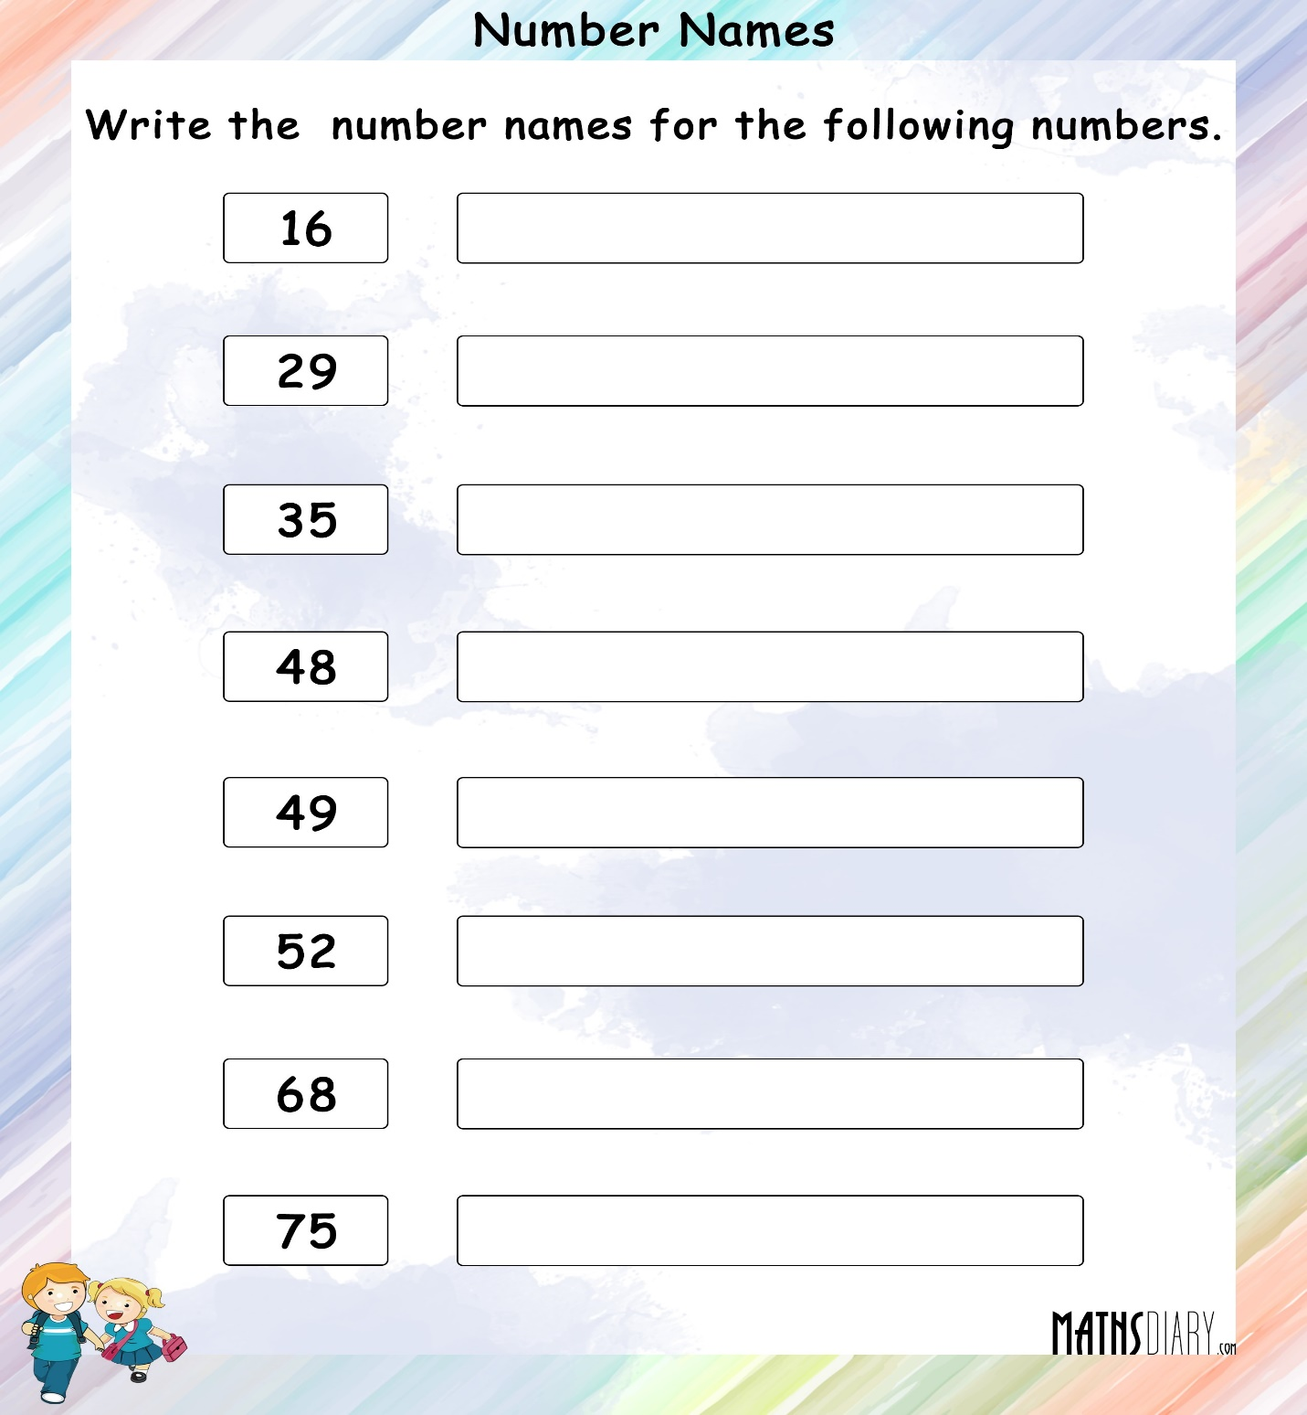

***Grade 1***

***Worksheet 10***

***Q: 1 less and I more than?***

